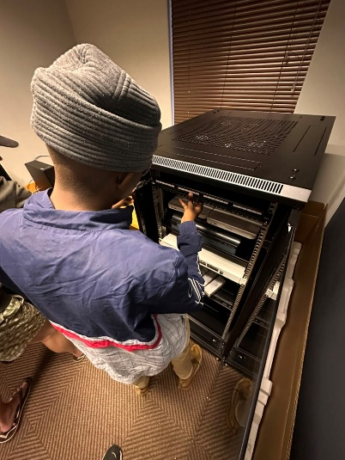
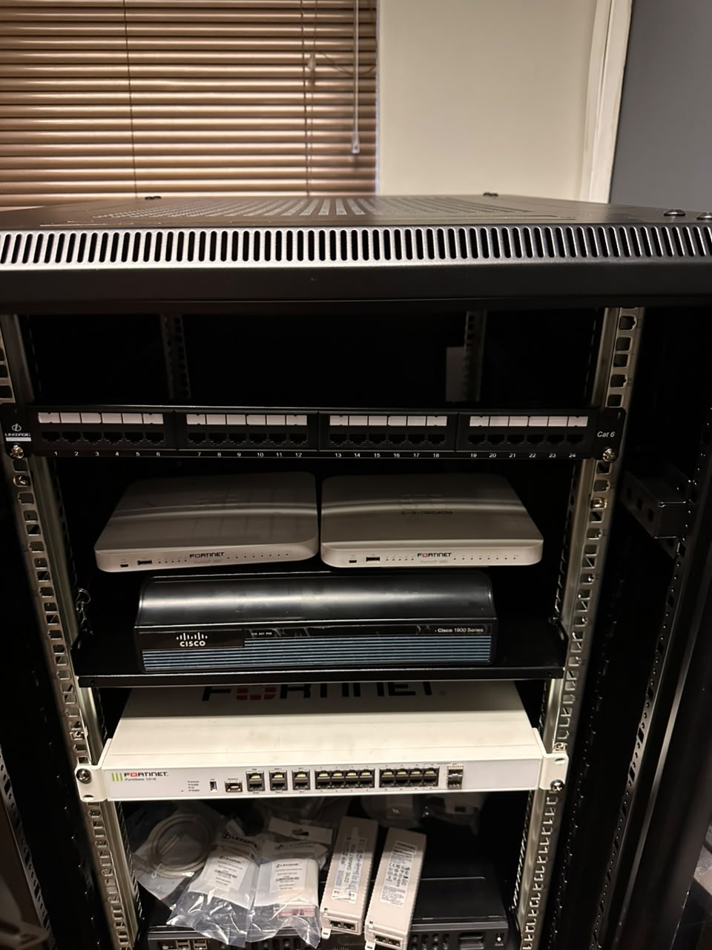
A patch panel is a piece of networking equipment that acts like a central hub for connecting and organizing cables in a network. Think of it as where all the wires from different devices (like computers, servers, and switches) come together neatly.
It servers as central hub
as the network grows, you can add more cables and devices without chaos, since everything is centralized.
